CN | CliffsNotes™ STYLE GUIDE  The Threat of Communism to the United States  Paper 5 of a Six-Part Series | 05
THE LONG ARM OF BEIJING
The FBI opens a new China counterintelligence case every 12 hours. Here's why.

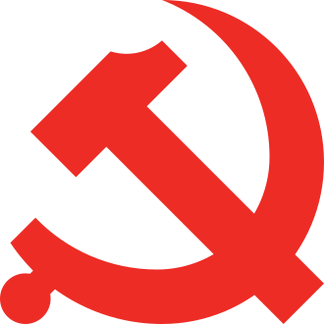
INSIDE THIS GUIDE:
★ The Big Idea — what this paper is really about
★ Key Players — who did what and why it mattered
★ Key Terms — the vocabulary you need
★ Section Summaries — the essential facts
★ Did You Know? — facts that surprise
★ The Bottom Line — what to remember
★ Think About It — discussion questions

★ THE BIG IDEA

The Chinese Communist Party has a department whose entire job is to infiltrate American universities, courts, politics, media, and diaspora communities. Most Americans have never heard of it. It's called the United Front Work Department, it reports directly to Xi Jinping, and it is operating right now in cities, campuses, and consulates across the United States. This is not speculation — it's documented in federal indictments and congressional testimony.

★ KEY PLAYERS

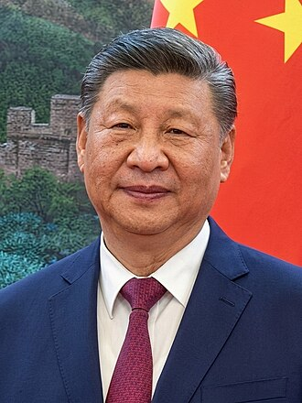 | Xi Jinping  1953–present | The Director  "The East is rising; the West is declining."  CLIFF'S TAKE: General Secretary of the Chinese Communist Party, President of the People's Republic of China, and Chairman of the Central Military Commission — he holds more concentrated personal power than any Chinese leader since Mao Zedong. His official salary is approximately $22,000 per year. Intelligence analysts estimate his family's proxied fortune at hundreds of billions of dollars in assets controlled through party networks and state enterprises. He oversees the UFWD directly. He considers the 'rejuvenation of the Chinese nation' a historic mission — by whatever means necessary.

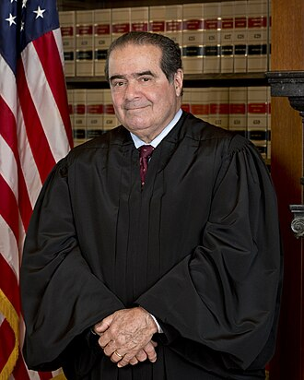 | Charles Lieber  1959–present | The Harvard Chair  "(Declined to comment.)"  CLIFF'S TAKE: Chairman of Harvard University's Department of Chemistry and Chemical Biology — one of the most prestigious academic positions in the world. Secretly signed a contract with Wuhan University of Technology paying him $50,000 per month plus $158,000 per year in living expenses while continuing to receive NIH and DOD grants he failed to disclose. Convicted in December 2021. The case was not about passing state secrets; it was about hiding a financial arrangement with a Chinese university from his employers and federal funders. This is the Thousand Talents model: not always spying — sometimes just concealment.

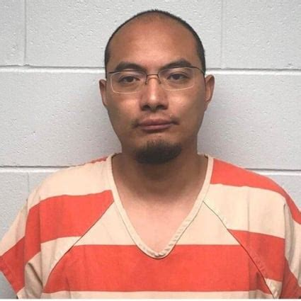 | Yanjun Xu  Unknown | The First MSS Officer Ever Extradited to the US  CLIFF'S TAKE: A Deputy Division Director in the Ministry of State Security's Sixth Bureau — a senior intelligence officer. Spent years cultivating contacts at American aerospace companies, including GE Aviation, and recruiting insiders to provide technical documents on advanced turbofan engine technology. Made the fatal mistake of traveling to Belgium for an academic conference, where US-requested Belgian authorities arrested him. Convicted in 2021, sentenced to 20 years. No MSS officer had ever been successfully extradited to face US prosecution before him. He is now in federal prison.

★ KEY TERMS YOU NEED TO KNOW

UFWD | United Front Work Department. A department of the Chinese Communist Party (not the government) that coordinates influence operations targeting overseas Chinese communities, foreign politicians, academics, and diaspora groups.

MSS | Ministry of State Security. China's combined CIA/FBI equivalent. Conducts espionage, recruits agents, and runs covert intelligence operations. Different from the UFWD — MSS collects intelligence; UFWD shapes influence.

Thousand Talents | A CCP program (2008–present) that recruited overseas scientists and researchers to transfer technology to China, typically while they maintained their US positions and funding — without disclosing the Chinese arrangement.

§ 951 | 18 U.S.C. § 951. Federal crime of acting as an unregistered agent of a foreign government. Does NOT require proof of espionage — only that the defendant acted 'at the direction or control' of a foreign government without notifying the Attorney General.

CIPA | Classified Information Procedures Act (1980). Allows classified evidence to be used in federal trials through substitutions and summaries, without compromising intelligence sources and methods. Critical in CCP cases where evidence comes from signals intelligence.

110 Overseas | Safeguard Defenders' term for the unauthorized CCP 'police service stations' discovered operating in cities worldwide — including New York City — conducting covert Chinese government law enforcement functions against Chinese nationals abroad.

★ THE SUMMARY

Meet the UFWD
The United Front Work Department (统一战线工作部) is not a government agency — it is an organ of the Chinese Communist Party itself, reporting directly to the Politburo Standing Committee. Founded by Mao Zedong in 1942, substantially expanded by Xi Jinping, its official mandate is to 'unite all forces that can be united' behind CCP objectives.
In practice, this means identifying, cultivating, and mobilizing non-Party actors — overseas Chinese communities, foreign politicians, academics, business executives — to advance CCP interests. Unlike the MSS (which conducts espionage) or the PLA (which conducts cyber operations), the UFWD's primary tool is influence, not collection. It shapes narratives, builds dependencies, and silences dissent.

❝ | "We're opening a new China-related counterintelligence case about every 12 hours. Of the nearly 5,000 active FBI counterintelligence cases currently underway across the country, almost half are China related."  — FBI Director Christopher Wray, Senate Intelligence Committee testimony (2022)

Six Ways the CCP Operates in America
The UFWD does not use a single channel. Its US operations include:
1. ACADEMIC: Thousand Talents Program — 500+ researchers documented at US universities receiving covert Chinese government payments (Senate PSI, 2019). Confucius Institutes — 100+ US universities closed them after investigation found CCP control over programming.
2. CAMPUS NETWORKS: Chinese Student and Scholar Associations, cultivated by Chinese consulates as reporting networks on student political views.
3. ELITE CAPTURE: Cultivating politicians, executives, and academics through business deals, speaking fees, and fellowships. The Fang Fang / Congressman Swalwell case is the most documented US example.
4. COVERT POLICE: 110 Overseas stations — unauthorized CCP offices conducting law enforcement against Chinese nationals. NYC station raided by FBI April 2023.
5. TRANSNATIONAL REPRESSION: Operation Fox Hunt/Skynet — CCP agents operating in the US to coerce Chinese dissidents into returning to China by threatening their families.
6. MEDIA: China Daily (FARA-registered), CGTN, Xinhua, and WeChat surveillance of overseas Chinese communities.

📌 DID YOU KNOW?
WeChat, used by millions of Chinese-Americans to communicate with family in China, is monitored by the CCP under China's National Security Law. Content critical of the Chinese government is removed. Users who post politically sensitive material risk having accounts reported to authorities — with consequences for family members still in China. This amounts to censorship and surveillance on US soil.

Why Prosecution Was Possible
CCP influence operations look very different from classic espionage, but the US legal framework has proven adaptable:
▸ 18 U.S.C. § 951 (Foreign agent statute): Doesn't require proof of actual espionage — only that the defendant acted at a foreign government's direction without registering. Used in the NYPD Angwang case and 110 Overseas prosecution.
▸ Economic Espionage Act (18 U.S.C. §§ 1831–1839): Targets trade secret theft for the benefit of a foreign government. Used in Lieber and Xu cases.
▸ CIPA: Allows classified intelligence evidence to be used in open court through legal substitutions. Without CIPA, many CCP cases would be unprosecutable.
▸ DOJ China Initiative (2018–2022): Dedicated prosecutorial program that sharply increased China-related cases. Terminated in 2022 after criticism of racial profiling — the underlying authorities remain in effect.

⬛ THE BOTTOM LINE
The CCP's influence operations in America are not a movie plot. They are documented in federal indictments, congressional testimony, and court records. The UFWD targets universities, politicians, businesses, and diaspora communities using methods that range from financial inducements to coercion and blackmail. The US legal framework has shown it can prosecute these operations — but requires sustained investment in counterintelligence and a clear-eyed willingness to name the threat without painting all Chinese-Americans with the same brush.

★ THINK ABOUT IT

Q1. The UFWD targets overseas Chinese communities as both a surveillance network AND a recruitment pool. If you were a Chinese-American student, how would that knowledge affect your behavior? What would you do differently?
Q2. The China Initiative increased CCP-related prosecutions but was criticized for racial profiling — 90% of defendants were of Chinese origin. How should the government balance national security needs against the civil liberties of an ethnic community?
Q3. Confucius Institutes were described as educational and cultural programs. More than 100 US universities closed them after investigation. Were those closures justified? What principle should govern when foreign government-funded programs are acceptable and when they're not?

