CN | CliffsNotes™ STYLE GUIDE  The Threat of Communism to the United States  Paper 4 of a Six-Part Series | 04
CLEARING THE AIR ON GOVERNMENT TERMINOLOGY
There are only so many ways to run a country. Some protect you. Some eat you.

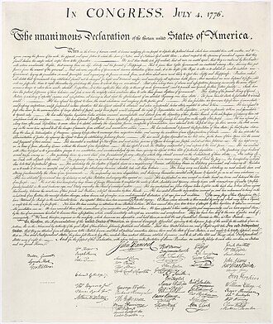
INSIDE THIS GUIDE:
★ The Big Idea — what this paper is really about
★ Key Players — who did what and why it mattered
★ Key Terms — the vocabulary you need
★ Section Summaries — the essential facts
★ Did You Know? — facts that surprise
★ The Bottom Line — what to remember
★ Think About It — discussion questions

★ THE BIG IDEA

The words 'democracy,' 'republic,' 'socialism,' 'fascism,' 'communism,' and 'dictatorship' are thrown around constantly in American political discourse — almost always incorrectly. Precision matters because vague vocabulary enables vague thinking, and vague thinking is how bad ideas get a free pass. This paper defines the major government types, gives real examples, and reveals what the world actually looks like today.

★ KEY PLAYERS

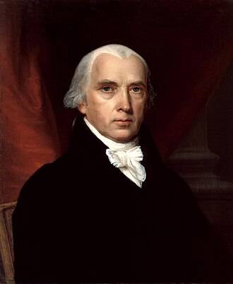 | James Madison  1751–1836 | The Architect of American Government  "If men were angels, no government would be necessary."  CLIFF'S TAKE: The principal author of the US Constitution and the Bill of Rights, and one of the primary contributors to The Federalist Papers. Madison was obsessed with a single problem: how do you build a government powerful enough to govern but unable to become tyrannical? His answer — separation of powers, federalism, checks and balances, enumerated rights — has held for 250 years. He would have immediately recognized the dangers described in Papers 5 and 6 of this series.

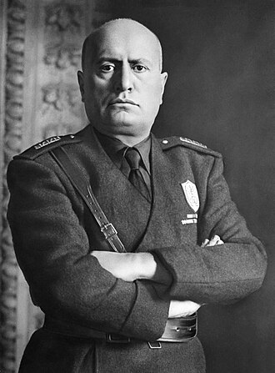 | Benito Mussolini  1883–1945 | The Inventor of Fascism  "The definition of fascism is the marriage of corporation and state."  CLIFF'S TAKE: A former socialist who invented Fascism as a response to Communism — specifically, as a movement that would preserve Italian national identity against both Marxist internationalism and liberal democracy. He coined the term 'fascism' (from 'fascio,' Italian for 'bundle' — unity through collective force). His regime was brutal but produced Italy's first modern highway system. He was executed by Italian partisans in 1945 and his body hung upside down at a Milan gas station. History has delivered its verdict.

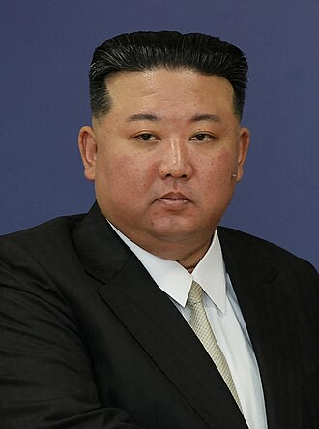 | Kim Jong-Un  1984–present | The Third-Generation Dictator  CLIFF'S TAKE: The grandson of Kim Il-sung, who founded North Korea's Communist state in 1948. Kim Jong-Un inherited a country where 25 million people have essentially no knowledge of the outside world, where owning a foreign movie is a capital offense, and where the official ideology — 'Juche' — holds that North Korea is the most perfect society in human history. He has tested nuclear weapons 45+ times. He is one of the five remaining Communist leaders on earth. His people earn an average of $1,700 per year.

★ KEY TERMS YOU NEED TO KNOW

Democracy | Rule by the people, typically through elected representatives. Can take many forms. The US is a representative democracy (not a direct democracy — citizens don't vote on every law).

Republic | A form of government where power is held by elected representatives accountable to citizens, with constitutional limits on government power. The US is both a democracy AND a republic. These are not opposites.

Federalism | A system where power is divided between a central national government and regional (state/provincial) governments. The US, Germany, and Australia are federal systems.

Fascism | Ultranationalist single-party system emphasizing national unity, strong military, and often a cult of personality around a leader. Anti-Communist and anti-liberal. Mussolini (Italy) and Hitler (Germany) are the canonical examples.

Totalitarianism | Control not just of government and economy, but of private life — thought, expression, religion, family relationships. Distinguishes itself from mere authoritarianism by attempting to control what you think, not just what you do.

Dictatorship | Rule by a single person or small group, without constitutional limits or accountability. Subtypes include military junta, personalist, and single-party systems.

★ THE SUMMARY

Democracy, Republic, and Federalism — The Distinctions
These three terms describe overlapping but distinct concepts. Democracy describes who holds power (the people, through elections). Republic describes HOW that power is structured (through elected representatives with constitutional limits). Federalism describes HOW power is distributed (between national and state governments).
The US is all three simultaneously. Many Americans incorrectly believe 'republic' and 'democracy' are opposites — this confusion is deliberately cultivated to suggest that majority rule is dangerous. It isn't. The Founders' concern was unlimited majority rule (mob rule). Their solution — checks, balances, rights, federalism — was not an alternative to democracy but a structure that makes democracy durable.

📌 DID YOU KNOW?
Only 44 of approximately 195 countries qualify as 'Liberal Democracies' — where elections are genuinely competitive AND civil liberties are fully protected. That's less than 23% of the world's nations. Freedom is rarer than Americans, who have had it for 250 years, tend to assume.

Fascism: The Misunderstood 'Other' Extreme
Fascism is frequently mischaracterized — both as a right-wing variant of Communism and as simply 'very bad government.' It is neither. Fascism is a specific ideological movement that emerged in Italy and Germany in the 1920s–30s as an explicit ANTI-Communist force. Mussolini's Black Shirts fought Italian Communists in the streets. Hitler received financing from German industrialists specifically because they feared Communist expropriation of their factories.
Key Fascist characteristics: ultranationalism, single-party rule, leader cult, corporatist economics (state-directed private capitalism), glorification of violence and military, and suppression of class-based politics in favor of national unity. Fascism and Communism are ideologically OPPOSED — one is nationalism, the other internationalism; one preserves private property (under state direction), the other abolishes it.

❝ | "Fascism is not an article for export."  — Benito Mussolini (1932)

What the World Actually Looks Like Today
The global picture in 2024, according to Freedom House and the Economist Intelligence Unit Democracy Index:
▸ Liberal Democracy: ~44 countries (US, Germany, Japan, Canada, Australia)
▸ Electoral Democracy (elections but limited rights): ~50 countries (India, Brazil, Mexico)
▸ Hybrid/Competitive Authoritarian (rigged elections): ~28 countries (Russia, Turkey, Hungary)
▸ Single-Party Authoritarian: ~22 countries (China, Saudi Arabia)
▸ Communist (still officially Marxist-Leninist): 5 countries (China, Cuba, Vietnam, Laos, North Korea)
▸ Military Junta: ~8 countries (Myanmar, Guinea, Sudan)
▸ Absolute Monarchy/Theocracy: ~10 countries (Saudi Arabia, Iran, Vatican)
The picture: liberal democracy is a minority system. Most of humanity lives under some form of authoritarian rule.

⬛ THE BOTTOM LINE
Words matter. 'Fascism' and 'Communism' are not synonyms for 'government I disagree with.' They describe specific, historically documented systems with specific characteristics and specific records. Using these words precisely — and demanding that others use them precisely — is not pedantry. It is the first line of defense against ideas that can only succeed when they're allowed to hide behind vague vocabulary.

★ THINK ABOUT IT

Q1. The United States is described as both a 'democracy' AND a 'republic.' A common argument says 'we're a republic, not a democracy' — what does this usually mean politically, and is the distinction accurate?
Q2. Fascism and Communism are often placed at opposite ends of the political spectrum. But both are totalitarian, both use single-party rule, and both suppress opposition. What actually separates them? Is the left-right spectrum a useful way to compare them?
Q3. Only 44 countries qualify as liberal democracies. Given that number, do you think democracy is humanity's natural preference when given a free choice — or does it require specific conditions to take root and survive?

