CN | CliffsNotes™ STYLE GUIDE  The Threat of Communism to the United States  Paper 3 of a Six-Part Series | 03
SOCIALISM VS. COMMUNISM
Sweden is not Cuba. Denmark is not North Korea. These distinctions matter.

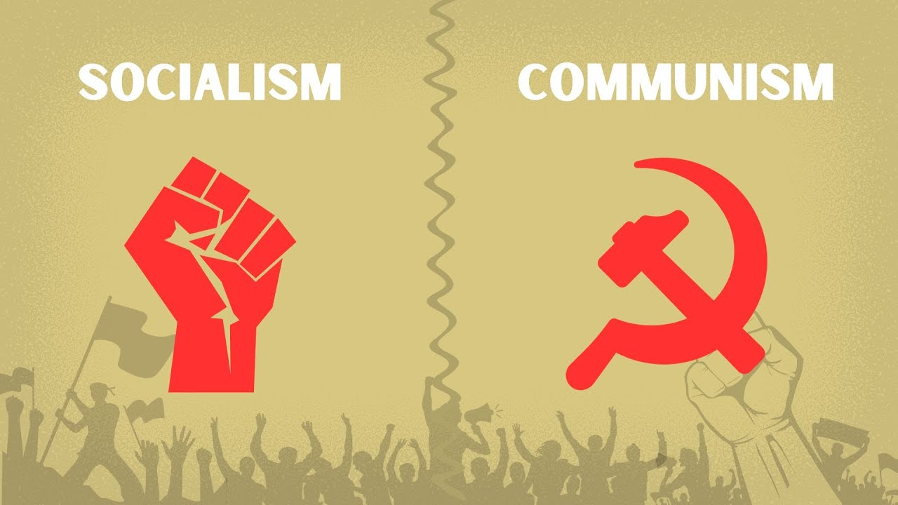
INSIDE THIS GUIDE:
★ The Big Idea — what this paper is really about
★ Key Players — who did what and why it mattered
★ Key Terms — the vocabulary you need
★ Section Summaries — the essential facts
★ Did You Know? — facts that surprise
★ The Bottom Line — what to remember
★ Think About It — discussion questions

★ THE BIG IDEA

Socialism and Communism are not the same thing. Americans on the right often use them interchangeably to scare people. Americans on the left often use them interchangeably to sound edgy. Both are wrong, and the confusion makes it impossible to have an honest conversation about public policy. This paper clarifies the distinctions — and then honestly examines the 'gateway drug' question.

★ KEY PLAYERS

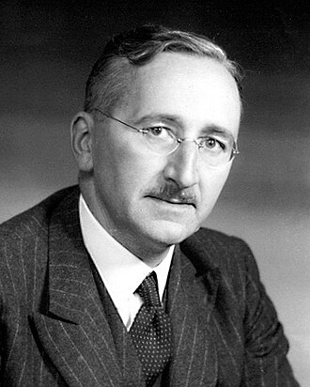 | Friedrich Hayek  1899–1992 | The Road-to-Serfdom Warning  "The curious task of economics is to demonstrate to men how little they really know about what they imagine they can design."  CLIFF'S TAKE: Austrian economist who wrote The Road to Serfdom (1944) while watching Nazi Germany and Soviet Russia both claim to be improving on capitalism. His central argument: once you give government control of the economy, political freedom becomes progressively harder to maintain — economic planning requires coercion, coercion requires concentrated power, concentrated power attracts the kind of person who enjoys using it. He won the Nobel Prize in 1974. Socialists said he was wrong. Venezuela said he might have been right.

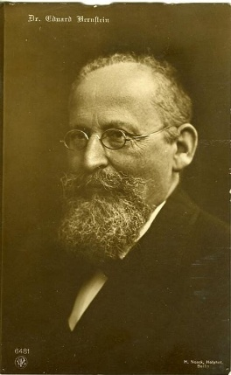 | Eduard Bernstein  1850–1932 | The Revisionist  "The goal is nothing; the movement is everything."  CLIFF'S TAKE: The German Social Democrat who first argued that Marxism didn't have to end in violent revolution — that workers could achieve socialism through democratic elections and gradual reform. Marx's surviving associates were furious. History suggests Bernstein was more right than wrong about the path, even if he was too optimistic about the destination.

 | Bernie Sanders  1941–present | America's Most Famous Democratic Socialist  "The issues facing working-class Americans... are not going away."  CLIFF'S TAKE: A self-described Democratic Socialist who has represented Vermont in Congress since 1990. He campaigns against 'millionaires and billionaires.' He is a millionaire. He owns three houses. He is worth approximately $2.5 million. In 2019, when asked whether it was problematic that he'd become a millionaire, he replied: 'I don't think it's appropriate for me to be talking about my personal finances.' The irony is bipartisan — see also: most politicians.

★ KEY TERMS YOU NEED TO KNOW

Means of Production | The tools, factories, and resources used to produce goods. Marx said whoever owns these controls society. The central question is: should these be privately owned (capitalism), collectively owned (socialism), or state-owned (Communism)?

Democratic Socialism | Advocates for social ownership of key industries through democratic political processes. Revolutionary change, but via ballots not bullets.

Social Democracy | A market economy with a strong welfare state. NOT the same as democratic socialism. Nordic countries are social democracies — they have robust capitalism AND robust safety nets.

Nordic Model | The economic model of Scandinavia: free-market capitalism + generous welfare state + strong labor unions + high taxes. Consistently produces among the highest living standards, least corruption, and highest happiness rankings in the world.

The Gateway Drug Question | Does adopting socialist policies inevitably lead a country toward Communism? Hayek said yes (Road to Serfdom). Nordic evidence says the key variable is whether democratic institutions remain strong.

Utopian Socialism | Robert Owen, Charles Fourier, Henri Saint-Simon — early 19th century thinkers who believed cooperative communities could be designed from scratch. Most of their experimental communities failed within a generation.

★ THE SUMMARY

What Socialism Actually Is (and Isn't)
Socialism is an economic theory, not a single political system. At its core, it holds that key industries — utilities, healthcare, transportation, sometimes manufacturing — should be owned collectively rather than by private individuals. But socialism exists on a wide spectrum:
▸ Utopian Socialism (Owen, Fourier): Let's design cooperative communities from scratch.
▸ Marxist Socialism: Revolution will seize the means of production for the workers.
▸ Democratic/Revisionist Socialism (Bernstein): We can get there through democratic reform.
▸ Social Democracy (modern Nordic model): Strong safety net over a market economy.
The word 'socialism' covers all of these. Using it without a modifier is meaningless.

📌 DID YOU KNOW?
The United States already has significant socialist elements: Medicare, Medicaid, Social Security, public schools, the interstate highway system, municipal water utilities, and the US Postal Service are all government-owned or operated services. Almost nobody calls these 'Communist.'

Where Socialism Ends and Communism Begins
The critical differences: Socialism CAN operate within a democratic system — you can vote for a socialist party, elect a socialist government, and vote it out if you don't like the results. Communism, as defined by Marx and implemented by Lenin, is a one-party system where opposition is not permitted and elections (when held) are not competitive.
Socialism preserves private property in some sectors. Communism abolishes it entirely. Socialism advocates gradual reform or democratic change. Communism advocates revolutionary seizure of power. Socialism has a sustainable moderate form (see: Norway). Communism has no sustainable moderate form — every attempt at 'moderate' Communism has either been crushed (Prague Spring, 1968) or evolved into capitalism (China, partially).

❝ | "It is not the consciousness of men that determines their existence, but their social existence that determines their consciousness."  — Karl Marx, A Contribution to the Critique of Political Economy (1859)

The Gateway Drug Question: Does Socialism Lead to Communism?
Hayek's argument in The Road to Serfdom (1944) is elegant: once you permit central planning of the economy, the logic of planning requires ever-more comprehensive control. Eventually, you need to compel people to follow the plan. Compulsion requires power. Power attracts authoritarians. Therefore: socialism slides toward Communism.
The Nordic counter-evidence: Sweden, Denmark, Norway, and Finland have maintained robust democratic socialism for 80+ years without sliding toward Communism. Their democratic institutions — independent courts, free press, competitive elections — appear to be the key variable. Hayek's mechanism is real but not inevitable; it can be blocked by strong institutional guardrails.
The Venezuela/Cuba cautionary tales: Both began with genuine democratic support for socialist programs. Both saw those programs captured by authoritarian leaders who used the expansion of state economic power to concentrate political power. Both are now authoritarian states. The institutions were not strong enough to hold.

⬛ THE BOTTOM LINE
Socialism is not Communism, but the relationship is real and complicated. The Nordic countries work because they maintain strong democratic institutions that prevent socialist economic policy from sliding into authoritarian political control. Venezuela and Cuba are cautionary tales of what happens when those institutions are weak. The gateway is real. Whether you walk through it depends almost entirely on the strength of your democracy — not the level of your social spending.

★ THINK ABOUT IT

Q1. Is it meaningful to call the US Postal Service 'socialist'? What about Social Security? If some government ownership is acceptable, where do you draw the line — and how do you draw it without sliding toward more?
Q2. Hayek wrote The Road to Serfdom in 1944. Nordic countries adopted social democratic policies around the same time. 80 years later, they haven't slid toward Communism. Does this refute Hayek, or does it confirm him with an asterisk?
Q3. Bernie Sanders calls himself a Democratic Socialist but says he's inspired by the Nordic model — which economists classify as Social Democracy, not Democratic Socialism. Does the distinction matter? Why or why not?

