CN | CliffsNotes™ STYLE GUIDE  The Threat of Communism to the United States  Paper 2 of a Six-Part Series | 02
THE SEDITION ACT & AMERICA'S LEGAL SHIELD
You can say almost anything in America. Almost.

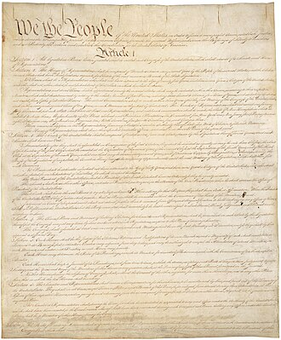
INSIDE THIS GUIDE:
★ The Big Idea — what this paper is really about
★ Key Players — who did what and why it mattered
★ Key Terms — the vocabulary you need
★ Section Summaries — the essential facts
★ Did You Know? — facts that surprise
★ The Bottom Line — what to remember
★ Think About It — discussion questions

★ THE BIG IDEA

The First Amendment protects free speech. The Sedition Act of 1918 tried to limit it. The Supreme Court spent 50 years figuring out where the line was. Brandenburg v. Ohio (1969) finally drew it in a place that has held ever since: you cannot be prosecuted for speech unless you are ACTIVELY inciting IMMINENT lawless action. January 6, 2021 showed what happens when that line is crossed.

★ KEY PLAYERS

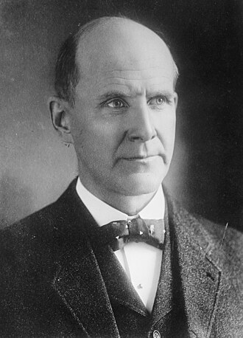 | Eugene V. Debs  1855–1926 | The Man Who Ran for President from Prison  "While there is a lower class, I am in it; while there is a criminal element, I am of it; while there is a soul in prison, I am not free."  CLIFF'S TAKE: A railroad union organizer and five-time Socialist Party presidential candidate who gave an anti-war speech in Canton, Ohio in 1918 and was sentenced to 10 years in federal prison for it. He ran for president FROM HIS PRISON CELL in 1920 and received 913,693 votes — roughly 3.4% of the total. President Wilson called him 'a traitor to his country.' President Harding released him in 1921. Debs shook hands with prison guards on the way out.

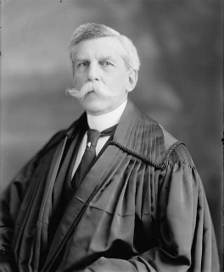 | Oliver Wendell Holmes Jr.  1841–1935 | The Justice Who Changed His Mind  "The most stringent protection of free speech would not protect a man from falsely shouting fire in a theatre."  CLIFF'S TAKE: Wrote the unanimous Schenck v. U.S. decision in March 1919 upholding the Sedition Act under the 'clear and present danger' test — and then, in October 1919, wrote a famous DISSENT in Abrams v. U.S. arguing the government had gone too far. In eight months, he effectively changed his mind on one of the most important free speech questions in American history. Constitutional law is messy like that.

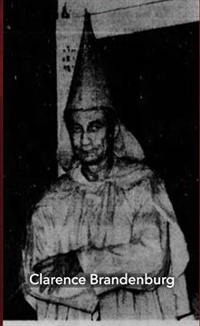 | Clarence Brandenburg  1920s–unknown | The KKK Leader Who Set the Free Speech Standard  CLIFF'S TAKE: A Ku Klux Klan leader in rural Ohio who burned a cross at a rally, used racial slurs on camera, and threatened 'revengeance' against politicians who suppressed the Klan. His 1969 Supreme Court case — Brandenburg v. Ohio — overturned his conviction and established that even hateful speech is protected unless it is 'directed to producing imminent lawless action AND is likely to produce such action.' The irony of one of America's ugliest figures establishing one of its most important civil liberties precedents is not lost on historians.

★ KEY TERMS YOU NEED TO KNOW

Sedition | Speech, conduct, or material that incites rebellion against the authority of a government. Not to be confused with 'criticism of the government,' which is entirely legal and specifically protected.

Clear & Present Danger | Holmes's 1919 test: speech can be restricted if it poses a 'clear and present danger' of producing illegal acts. Largely replaced by the Brandenburg test.

Brandenburg Test | The current First Amendment standard (1969): government can only restrict speech if it is (1) directed to inciting imminent lawless action AND (2) likely to produce such action. Both conditions must be met.

Smith Act | 18 U.S.C. § 2385. Still on the books. Makes it a federal crime to knowingly advocate the overthrow of the US government by force. Used to prosecute Communist Party leaders in the 1940s–50s.

FARA | Foreign Agent Registration Act. Requires anyone acting as an agent of a foreign principal in the US to disclose that relationship to the DOJ. Failure is a federal felony.

Seditious Conspiracy | 18 U.S.C. § 2384. Conspiring to overthrow the government, seize government property by force, or prevent by force the execution of US law. Used to convict Oath Keepers leadership after January 6.

★ THE SUMMARY

The Sedition Act of 1918: Wartime Panic
World War I produced a unique political atmosphere: a government at war, terrified of both German spies and domestic socialist opposition, with no established legal framework for either. Congress passed the Espionage Act (1917) and the Sedition Act (1918) in rapid succession. The Sedition Act made it a federal crime to 'willfully utter, print, write, or publish any disloyal, profane, scurrilous, or abusive language about the form of government of the United States.'
Read that again: 'abusive language about the form of government.' Under that standard, this paper could have been prosecuted. Over 2,000 people were charged under these acts; Eugene Debs was the most famous.

📌 DID YOU KNOW?
The Sedition Act of 1918 was repealed in 1921. However, the Espionage Act of 1917 — and with it, much of the same legal machinery — was NOT repealed. It's still on the books. Whistleblowers Edward Snowden and Chelsea Manning were both charged under it.

The Supreme Court's 50-Year Journey
From 1919 (Schenck) to 1969 (Brandenburg), the Supreme Court gradually narrowed the government's ability to prosecute speech. Schenck (1919) gave us 'clear and present danger.' Abrams (1919) saw Holmes dissent from his own earlier standard. Dennis v. United States (1951) upheld convictions of Communist Party leaders. Yates v. United States (1957) distinguished between advocating abstract doctrine and advocating concrete action. Brandenburg v. Ohio (1969) synthesized everything into the test that still stands: imminence AND likelihood of actual lawless action.

❝ | "The best test of truth is the power of the thought to get itself accepted in the competition of the market."  — Justice Holmes, dissenting in Abrams v. U.S. (1919)

January 6: The Modern Test
The January 6, 2021 attack on the US Capitol produced the first seditious conspiracy convictions in American history in decades. Stewart Rhodes (Oath Keepers founder) and Enrique Tarrio (Proud Boys leader) were convicted of seditious conspiracy under 18 U.S.C. § 2384. The government successfully argued that their coordinated efforts to prevent the certification of the 2020 Electoral College vote constituted a conspiracy to use force against a lawful government function.
The prosecutions — over 900 cases in total — demonstrated that the legal framework against sedition and insurrection is functional when prosecutors are willing to use it, and when the evidence is strong enough to meet the Brandenburg standard.

⬛ THE BOTTOM LINE
You can legally advocate for radical change in America — including advocating for socialism, for repealing the Second Amendment, for vastly expanding government power. What you cannot do is direct others to use imminent force to accomplish it. That line is narrow, but it's real. The January 6 prosecutions showed it can be enforced. The 900+ cases pending showed it can be scaled.

★ THINK ABOUT IT

Q1. Eugene Debs got 10 years in prison for a speech. Under the Brandenburg test (1969), would that same speech be protected today? What changed?
Q2. The Brandenburg test requires both 'imminent' action AND 'likelihood' of action. How would you apply that test to social media posts calling for political violence?
Q3. Should the United States have laws against sedition at all, given that it is a democracy where political change is theoretically possible through the ballot box? What's the argument on each side?

