CN | CliffsNotes™ STYLE GUIDE  The Threat of Communism to the United States  Paper 1 of a Six-Part Series | 01
HISTORY OF COMMUNISM
The theory that killed 94 million people and still hasn't admitted it.

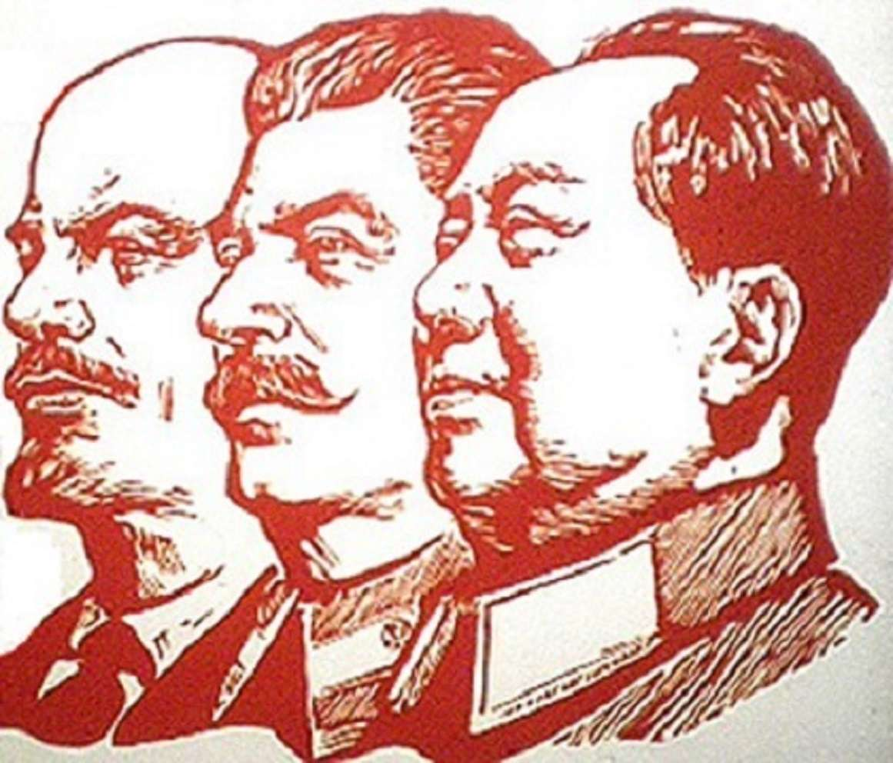
INSIDE THIS GUIDE:
★ The Big Idea — what this paper is really about
★ Key Players — who did what and why it mattered
★ Key Terms — the vocabulary you need
★ Section Summaries — the essential facts
★ Did You Know? — facts that surprise
★ The Bottom Line — what to remember
★ Think About It — discussion questions

★ THE BIG IDEA

Between 1917 and today, Communism was tried in 42 countries across four continents. It promised to liberate the working class. It consistently produced famine, secret police, and a new ruling class. The experiment has now been run enough times to draw conclusions.

★ KEY PLAYERS

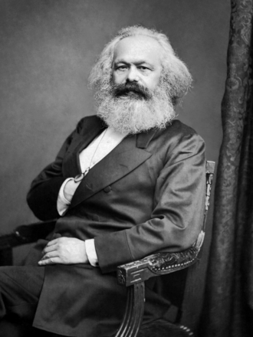 | Karl Marx  1818–1883 | The Theorist  "Workers of the world, unite!"  CLIFF'S TAKE: A bearded German philosopher who spent 30 years in the British Museum library predicting that industrial workers would revolt against factory owners. They never revolted in England or Germany — the countries he studied. They revolted in agrarian Russia, which he didn't predict. He died 34 years before anyone tried his ideas. His ideas killed approximately 94 million people in countries he never visited.

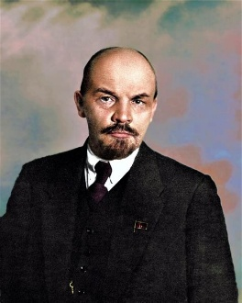 | Vladimir Lenin  1870–1924 | The First Implementer  "A lie told often enough becomes the truth."  CLIFF'S TAKE: A lawyer's son who turned Marxist theory into a functioning (if brutal) government in 1917. Invented the 'vanguard party' — the idea that professional revolutionaries should lead the workers, since the workers were apparently too busy working to lead themselves. Created the Soviet Union, then died before seeing what Stalin would do with it. In fairness, he might have been at least somewhat horrified.

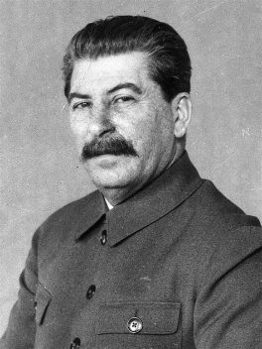 | Joseph Stalin  1878–1953 | The Monster  "Death solves all problems — no man, no problem."  CLIFF'S TAKE: Transformed the Soviet Union into an industrial power by killing roughly 20 million of its citizens. His agricultural collectivization policy (1930s) forcibly seized farms from private owners — called 'Kulaks' (wealthy peasants) — creating famines that killed millions. Once airbrushed inconvenient comrades out of official photographs. Had at least 750,000 people executed between 1936–1938 alone. Died peacefully in his bed in 1953, which is more than can be said for most of his contemporaries.

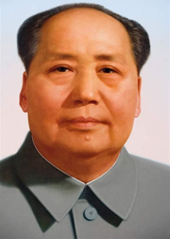 | Mao Zedong  1893–1976 | The Scale Problem  "Political power grows out of the barrel of a gun."  CLIFF'S TAKE: Holds the record for the most people killed by any leader in human history. His 'Great Leap Forward' (1958–1962) ordered China's rural population to smelt steel in backyard furnaces while ignoring crops. The resulting famine killed between 30 and 55 million people. The Chinese Communist Party still officially considers him '70% right.'

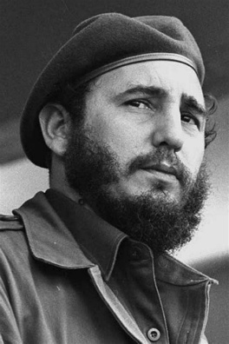 | Fidel Castro  1926–2016 | The Survivor  "History will absolve me."  CLIFF'S TAKE: Cuba's Communist leader outlasted 11 US presidents, the Soviet Union (his main benefactor), and most of his own Politburo. Cuban doctors earn approximately $25–30 per month. Hundreds of thousands of Cubans have risked their lives on rafts to reach Florida. When he died at 90, the Cuban government announced three days of national mourning. Attendance was mandatory.

★ KEY TERMS YOU NEED TO KNOW

Bourgeoisie | Marx's term for the capitalist class — factory owners, landlords, employers. In Communist theory, the villains.

Proletariat | The working class — factory workers, miners, laborers. In Communist theory, the heroes who will eventually seize power.

Collectivization | The forced transfer of privately owned farmland into state or collective control. In practice, this usually caused famine.

Vanguard Party | Lenin's concept: a small group of professional revolutionaries leads the revolution on behalf of workers who are too occupied with daily survival to organize themselves.

Iron Curtain | Churchill's 1946 phrase for the dividing line between Soviet-controlled Eastern Europe and the free West. It ran through the middle of Germany.

HUAC | House Un-American Activities Committee. Investigated Communist infiltration of US government, Hollywood, and unions from 1938–1975. Joseph McCarthy was a senator, not a HUAC member — common confusion.

★ THE SUMMARY

What Marx Actually Said
Marx argued that all of history was a series of class conflicts: slaves vs. slaveholders, serfs vs. nobility, workers vs. factory owners. He predicted that capitalism would eventually collapse under its own contradictions — wages would be driven to subsistence level, workers would become radicalized, and a global revolution would result. After a brief 'dictatorship of the proletariat,' the state would 'wither away,' leaving a classless, stateless society where everyone contributed what they could and received what they needed.
The theory had two fatal problems. First, it assumed the working class would naturally develop 'revolutionary consciousness' — they mostly didn't. Second, the 'withering away of the state' never happened. In every case, the state expanded dramatically and never withered at all.

📌 DID YOU KNOW?
The word 'Communism' appears ZERO times in the US Constitution. Neither does 'Democracy.' The Founders deliberately avoided both terms — they distrusted both mob rule and ideological systems.

The Russian Revolution: From Theory to Disaster
Russia in 1917 was not the industrialized country Marx described. It was a peasant agricultural society with a tiny factory workforce and a monarchy that had just lost 2 million men in World War I. Lenin seized the moment, overthrew the provisional democratic government (which he called 'bourgeois'), and imposed a one-party state.
The Bolsheviks (Lenin's party) immediately banned opposition parties, created the Cheka (secret police), confiscated private property, and began what they called 'war communism' — forced seizure of grain from peasants to feed the cities. When peasants resisted, they were shot. When workers went on strike for better conditions than they'd had under the Tsar, they were arrested. The proletarian revolution had arrived. The proletariat wasn't consulted.

❝ | "Freedom is so precious that it must be rationed."  — Vladimir Lenin

The Global Parade: Same Pattern, Different Countries
After World War II, Communist governments were installed across Eastern Europe (Soviet troops helped with the convincing), took power in China (1949), Cuba (1959), Vietnam (1975), Cambodia (1975), and elsewhere. In every case, the pattern was identical: nationalization of property, elimination of political opposition, secret police, restriction of movement, and a widening gap between the Party leadership's living standards and everyone else's.
The Black Book of Communism (1997), compiled by European scholars, estimated the total death toll under Communist regimes at approximately 94 million people — the equivalent of wiping out the entire population of Germany and France combined.

📌 DID YOU KNOW?
The five Communist states that still exist today — China, Cuba, Vietnam, Laos, and North Korea — collectively govern approximately 1.5 billion people. Of these, none hold competitive elections. None have independent judiciaries. None permit organized political opposition.

The American Response
The United States responded to the Communist threat with a combination of legal tools, investigative agencies, and what historians politely call 'overreaction.' The FBI under J. Edgar Hoover tracked Communist Party USA members for decades. HUAC investigated Hollywood screenwriters, academics, and government employees. The McCarthy era (1950–1954) produced real cases of Communist infiltration (the Rosenbergs, Alger Hiss) alongside a much larger wave of false accusations that destroyed careers.
The legal toolkit — the Smith Act, the McCarran Internal Security Act, the Immigration and Nationality Act — gave the government powerful tools against sedition and subversion, some of which remain on the books today.

⬛ THE BOTTOM LINE
Communism is not an untested theory. It has been run as a real-world experiment in 42 countries, across multiple continents, over more than a century. The results are consistent and documented. Every Communist state produced authoritarian rule, economic failure, and a new privileged class that lived nothing like the workers it claimed to represent. The experiment is concluded. The results are in.

★ THINK ABOUT IT

Q1. Why do you think Marx's theory predicted revolution in industrial countries — but revolutions actually happened in peasant agricultural societies like Russia, China, and Cuba?
Q2. If you could ask Stalin or Mao one question, what would it be? What do you think they'd actually say — and what do you think they'd actually mean?
Q3. The Black Book of Communism estimates 94 million deaths. How should that number change (or not change) how we evaluate Communist theory vs. Communist practice?

