CN | CliffsNotes - The Problem with Iran  Paper 1: THE PROBLEM WITH IRAN  How a 2,500-year-old civilization was hijacked by theocrats — and what to do about it.

INSIDE THIS GUIDE:
• The Big Idea
• Key Players (5)
• Key Terms (6)
• The Summary (5 sections)
• Did You Know? (3)
• Bottom Line
• Think About It (4 questions)

★ THE BIG IDEA
Iran is two countries fused into one. The first is Persia — the civilization of Cyrus the Great, Esther the queen, Darius the Behistun engraver, and Hafez the poet — 2,500 years of literary, philosophical, and political continuity. The second is the Islamic Republic — a 46-year-old theocracy that seized power in 1979, took 52 Americans hostage for 444 days, killed 241 U.S. Marines in Beirut, helped the 9/11 hijackers transit through Tehran, and currently runs the largest state-sponsored terror network on Earth. The regime is the threat. The Iranian people are the heirs. Understanding the difference is the first step toward victory without war.
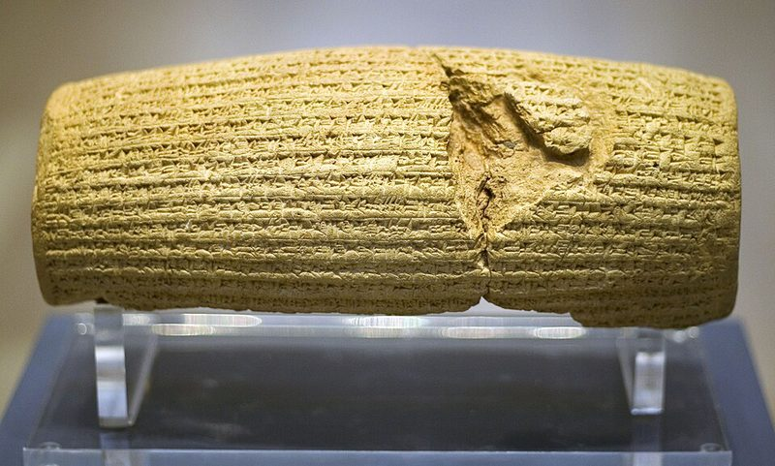
The Cyrus Cylinder (539 BCE) — antiquity’s earliest surviving document of state-sponsored religious tolerance.
★ KEY PLAYERS
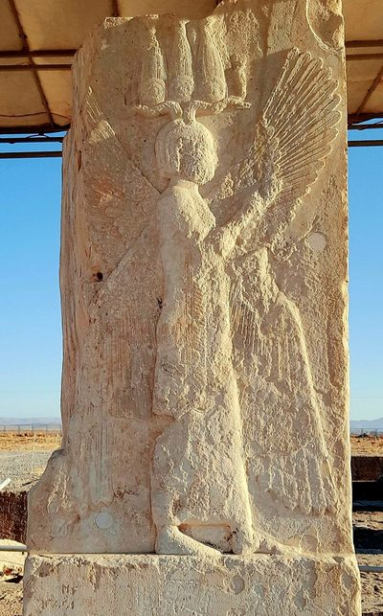 | Cyrus the Great  c. 600–530 BCE | The Liberator  Founder of the Persian Empire and the only foreign king the Hebrew Bible calls God's 'anointed' (Isaiah 45:1). Conquered Babylon in 539 BCE and immediately reversed Babylonian exile policy — releasing the Jews to rebuild the Jerusalem Temple. The Cyrus Cylinder, now in the British Museum, is antiquity's earliest surviving document of state-sponsored religious tolerance. Persia under Cyrus was, for a century of biblical history, the most consequential friend the Jewish people had outside of God Himself.  “Whoever is among you of all his people, may his God be with him, let him go up to Jerusalem... and rebuild the house of the Lord.”

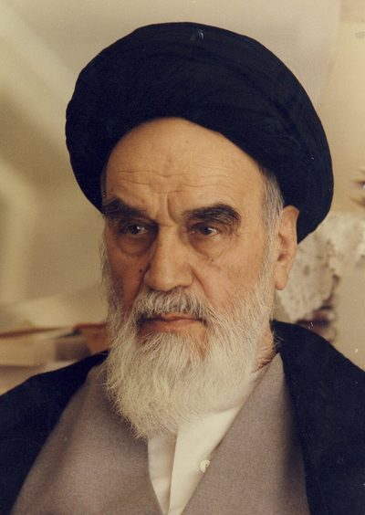 | Ruhollah Khomeini  1902–1989 | The Hijacker  A mid-ranking Qom ayatollah who spent 14 years in exile in Najaf and France building a global propaganda network on cassette tapes — history's first viral political content. In 1970 he published Velayat-e Faqih, the doctrine that clerics should rule directly. In 1979 he returned to Tehran on an Air France flight and turned a popular uprising against the Shah into a totalitarian theocracy. Endorsed the U.S. embassy seizure within 72 hours when he saw its mobilizing potential. Died in 1989 having institutionalized rule by Islamic jurist.  “America cannot do a damn thing against us.”

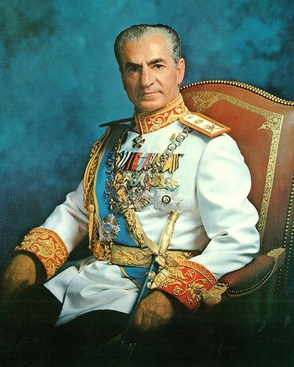 | Mohammad Reza Pahlavi  1919–1980 | The Last Shah  Took the throne at 21 after the Anglo-Soviet invasion of 1941. After the CIA-MI6 restoration in 1953, he ruled until 1979. His White Revolution (1963) brought women's suffrage, land reform, and literacy gains — and alienated the landed clergy and bazaari merchants whose endowments and networks it disrupted. His secret police SAVAK created the repression that fueled the revolutionary backlash. Fled Iran in January 1979, admitted to the United States for cancer treatment in October 1979 — the spark for the embassy seizure. Died in Egypt in July 1980, 18 months after losing his throne.  “I could not, as the Shah, in good conscience, accept anything less than the will of the Iranian people.”

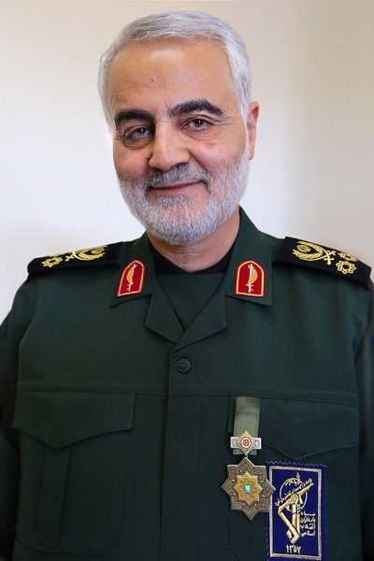 | Qassem Soleimani  1957–2020 | The Operator  Commander of the Quds Force, the external-operations arm of Iran's Islamic Revolutionary Guard Corps, from 1998 until his death. Built the Axis of Resistance — Hezbollah in Lebanon, Hamas in Gaza, Shia militias in Iraq, the Houthis in Yemen, and the Assad regime in Syria. Personally directed the supply of EFPs (explosively formed penetrators) to Iraqi militias that killed over 600 American troops between 2003 and 2011. Killed by a U.S. drone strike at Baghdad International Airport on January 3, 2020 — the highest-ranking foreign military officer the United States has killed in a generation.  “We are not a country that compromises with anybody on its national interests.”

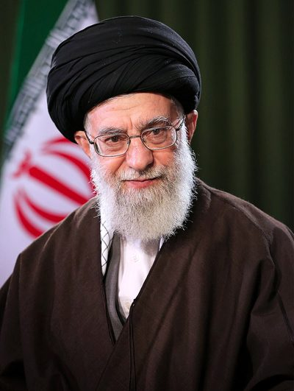 | Ali Khamenei  b. 1939 | The Supreme Leader  Khomeini's hand-picked successor, in power since 1989 — longer than any Iranian ruler since the 19th-century Qajars. Holds the constitutional title of Supreme Leader under Velayat-e Faqih, with authority over the military, the judiciary, the IRGC, and the right to overrule the elected president. Survived the Green Movement (2009), the fuel protests (2019), and the Mahsa Amini uprising (2022–2023) by killing protesters in the streets — 1,500 in 2019 alone. Personally approved every major terror operation against the United States and Israel of the past 35 years, including the proxy missile attacks on Israel in 2024.  “Death to America is not a slogan, it is a policy.”

★ KEY TERMS YOU NEED TO KNOW
Velayat-e Faqih | 'Guardianship of the Jurist.' Khomeini's 1970 doctrine that, in the absence of the 12th Imam, supreme political authority must rest with a senior cleric. The constitutional foundation of the Islamic Republic. Most senior Shia clerics historically rejected it — Najaf-school Shi'ism is quietist.
IRGC | Islamic Revolutionary Guard Corps. A parallel military to Iran's regular army, founded in 1979 to defend the revolution itself. Runs Iran's missile program, its proxy network through the Quds Force, and a large slice of the Iranian economy through front companies. Designated a Foreign Terrorist Organization by the U.S. in 2019.
Twelver Shia | The dominant branch of Shia Islam and Iran's state religion since the Safavid forced conversion of 1501. Believes in twelve Imams descended from Muhammad's son-in-law Ali; the twelfth, the Hidden Imam (Muhammad al-Mahdi), is said to have gone into occultation in 874 CE and will return at the end of time.
Operation Eagle Claw | April 24, 1980 — the failed U.S. military rescue of the 52 American hostages. Eight RH-53D helicopters from the USS Nimitz rendezvoused with C-130s at a desert airstrip in central Iran (Desert One). Sandstorms and mechanical failures reduced the helicopter count below the operational minimum. During withdrawal, an RH-53D collided with an EC-130 refueler. Eight Americans died. The failure birthed JSOC and the 160th SOAR ('Night Stalkers').
Axis of Resistance | Iran's regional proxy network: Hezbollah (Lebanon), Hamas (Gaza), the Houthis (Yemen), Iraqi Shia militias (Kataib Hezbollah, Asaib Ahl al-Haq), and — until December 2024 — the Assad regime in Syria. Coordinated by the IRGC's Quds Force. Built specifically to attack the United States and Israel without fingerprints traceable to Tehran.
Havlish v. bin Laden | Federal court case, S.D.N.Y., December 22, 2011. Judge George B. Daniels issued 276 findings of fact concluding that Iran, the IRGC, MOIS, and Hezbollah provided 'direct support' to al Qaeda for the 9/11 attacks — including travel facilitation through Iran for the 'muscle hijackers.' Default judgment against Iran: $7 billion-plus.

★ THE SUMMARY
Persia Before the Revolution
The land we call Iran is the oldest continuously functioning civilizational core in the modern Middle East. Long before Islam, the Achaemenid Empire under Cyrus, Darius, and Xerxes stretched from the Indus to the Aegean and produced the political and religious institutions that the Hebrew Bible records with admiration. After Alexander, the Parthians, and the Sassanids (the last pre-Islamic Persian empire), Arab armies overran Persia at the Battle of al-Qadisiyyah in 636 CE and the country was Islamized — often by force — over the next two centuries. Persians are not Arabs. The Persian language is Indo-European, kin to Sanskrit and Latin. The Shahnameh, composed around 1010 CE, deliberately used Persian rather than Arabic vocabulary to preserve national memory. Nowruz, the Persian New Year, predates Islam and is still celebrated in Tehran today — but you will not find it in the Arab world.
How Shi'ism Became the State Religion
In 1501, Shah Ismail I of the Safavid dynasty seized Tabriz and proclaimed Twelver Shia Islam the official religion of Persia — a country that had been overwhelmingly Sunni for 800 years. Conversion was enforced; Sunnis who resisted were killed or exiled. This is the origin of the modern Sunni-Shia geographic split between Iran and the Arab world. Twelver Shi'ism's defining belief is in twelve Imams descended from Muhammad's son-in-law Ali, with the twelfth — the Mahdi — in occultation since 874 CE and prophesied to return at the end of time, accompanied by Jesus, to establish global Islamic rule. Iranian regime figures including Ahmadinejad and Khamenei have invoked the imminent return of the Mahdi to justify policy. Most senior Shia clerics, including the Najaf school in Iraq, have historically been quietist and rejected direct clerical rule. Khomeini's Velayat-e Faqih (Guardianship of the Jurist) doctrine is only 56 years old — younger than most American homeowners' mortgages.
📌 DID YOU KNOW?
The Cyrus Cylinder (539 BCE), now in the British Museum, records Cyrus the Great's policy of returning displaced peoples to their homelands and restoring their sanctuaries. The United Nations holds a replica and has called it 'the world's first declaration of human rights.' The same civilization that produced it today executes converts to Christianity and imprisons Baha'is.

Oil, the Shah, and 1953
Modern Iran was born in 1908 when William Knox D'Arcy struck oil at Masjed Soleyman. The Anglo-Persian Oil Company (later BP) was founded, and Iran's economy was tied to a single export ever after. In 1935, Reza Shah Pahlavi renamed the country from 'Persia' to 'Iran' — 'land of the Aryans.' His son Mohammad Reza took the throne in 1941 after the Anglo-Soviet invasion. In 1951, Prime Minister Mohammad Mossadegh nationalized the oil company; in 1953, the CIA and British SIS executed Operation Ajax, overthrew Mossadegh, and restored the Shah's power. This is the historical grievance the Iranian regime cites to justify every action it has taken since 1979. The grievance is real. It does not, however, justify hostage-taking, terrorism, or the killing of Iranian citizens by their own government — and it does not give the regime an exclusive license to define what 'Iran' wants today.
❝ | There is strong evidence that Iran facilitated the transit of al Qaeda members into and out of Afghanistan before 9/11.  — The 9/11 Commission Report, p. 241 (2004)

The 1979 Hijacking and the Hostage Crisis
Khomeini did not lead a single street protest. He spent the entire revolution in Najaf and then Neauphle-le-Château, France. His weapon was the audio cassette tape — sermons smuggled into Iran and copied by hand, the world's first viral propaganda. By 1978, the cassette-fueled agitation produced street violence on the Shia 40-day mourning cycle. The Shah fled on January 16, 1979. Khomeini returned February 1 on an Air France flight with Western journalists. A March 1979 referendum offered the choice 'Islamic Republic — yes or no?' (98.2% yes). On November 4, 1979, Iranian students stormed the U.S. embassy in Tehran and took 52 Americans hostage for 444 days. President Carter's April 1980 rescue attempt, Operation Eagle Claw, failed at Desert One when a sandstorm and helicopter failures forced abort; during withdrawal, an RH-53D collided with an EC-130 and eight Americans died. The hostages were released minutes after Ronald Reagan's inauguration on January 20, 1981 — a final, calculated insult to Carter.
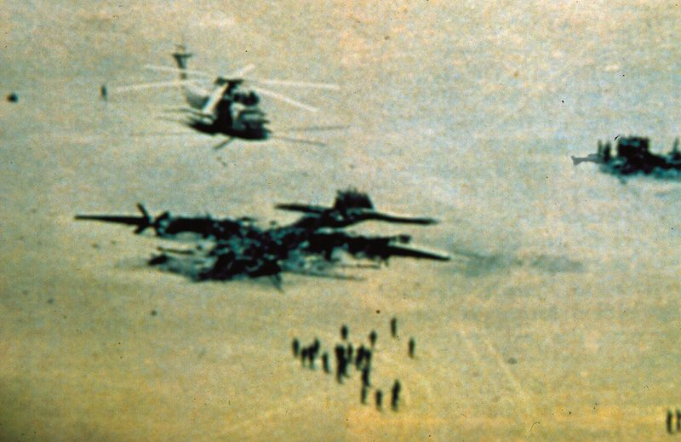
Wreckage at Desert One, April 25, 1980 — eight Americans killed in the failed rescue. U.S. DoD photo.
📌 DID YOU KNOW?
The April 1980 rescue mission, Operation Eagle Claw, failed so completely that it produced the Holloway Commission Report — which directly led to the creation of Joint Special Operations Command (JSOC) at Fort Bragg and the 160th Special Operations Aviation Regiment (the 'Night Stalkers'). Forty years later, those same units killed Osama bin Laden and Qassem Soleimani.

From Hostages to Hezbollah to 9/11 to Today
Iran was designated a State Sponsor of Terrorism on January 19, 1984 — the longest continuous SST designation on record. The Quds Force, the external-operations arm of the IRGC, built the proxy network: Hezbollah (founded 1982, killed 241 Marines in Beirut October 23, 1983); Hamas; Iraqi Shia militias that killed 600+ U.S. troops with Iranian-supplied EFPs; the Houthis. A federal court ruled in December 2011 that Iran provided material support to the 9/11 hijackers — eight to ten of the 'muscle hijackers' transited Iran in 2000–2001 with unstamped passports. Saif al-Adel, the current de facto leader of al Qaeda per the UN Monitoring Team, operates from Iranian soil today. But the regime is now weaker than at any point since 1979. Soleimani is dead (January 3, 2020). Hezbollah's leadership was decapitated in September 2024. Hamas leader Yahya Sinwar was killed October 17, 2024. The Assad regime collapsed in December 2024. Inflation in Iran exceeds 40%. Seventy percent of Iranians are under 35 and want nothing to do with the regime. Regime change — by the Iranian people, with sustained American pressure, without war — is the achievable goal.
📌 DID YOU KNOW?
Iran is currently subject to federal-court default judgments exceeding $50 billion in favor of American victims of terrorism — including the families of September 11 victims, the U.S. Marines killed in the 1983 Beirut barracks bombing, and others. These judgments are routinely enforced against seized Iranian assets abroad and against the United States Victims of State Sponsored Terrorism Fund.

⬛ THE BOTTOM LINE
Iran is not a country with a regime problem. It is a 2,500-year-old civilization currently held hostage by a 46-year-old theocracy. The regime has killed more Americans than any state actor since North Vietnam, harbors the leadership of al Qaeda, and is building nuclear weapons it has promised to use. Its proxy network has been shattered in the last 18 months. Its currency has collapsed. Seventy percent of Iranians want it gone. The path to victory is not war with Iran — it is the Iranian people, supported by sustained American pressure, finishing what they started in 2009, 2019, and 2022.

★ THINK ABOUT IT
Q1. Why do you think most Iranian protests over the past 15 years (2009, 2019, 2022) have been led by women and young people — and what does that tell you about who actually supports the regime?
Q2. The CIA participated in the 1953 overthrow of Mossadegh. The regime cites this every time it justifies its actions today. How should an American honestly evaluate that 70-year-old grievance — and where are its limits?
Q3. If the federal judiciary has ruled that Iran materially supported the 9/11 hijackers, and the executive branch has designated Iranian-based al Qaeda facilitators across four administrations — what is the moral status of current American restraint toward Iran?
Q4. The Iranian regime has been weakened more in 2024 than at any point since 1979 — Soleimani, Nasrallah, Sinwar, and Assad all gone. What does the historical record (1989 Eastern Europe, 1991 USSR) suggest about how regimes actually fall — and what role does external pressure play vs. internal collapse?

